Hybrid Approach for Predictive Maintenance in Automobiles: Integrating Random Forest and LSTM Models

Drupath S Prasad
Department Of Computer Science
Sacred Heart College Thevara,Kochi,India
Mrs. Aliya Teresa T.M
Department Of Computer Science
Sacred Heart College Thevara,Kochi,India

ABSTRACT
Recent trends in the automobile industry highlight the importance of identifying potential problems or failures in vehicles ahead of time. Taking preventive action can save significantly more money compared to addressing issues after they occur. As the old saying goes, 'Prevention is better than cure,' and this applies perfectly to automobiles. As a result, many Predictive Maintenance (PdM) algorithms have been developed using machine learning to predict and prevent these issues. These algorithms help determine the remaining lifespan of a vehicle before a failure occurs, enabling timely and appropriate action. This literature review aims to analyse various research papers on this topic and provide a concise summary of their findings.

Keywords : Predictive Maintenance, Machine Learning, Automotive Industry, Vehicle Maintenance, Artificial Intelligence

1. INTRODUCTION

The traditional maintenance approaches in the automobile industry, such as preventive maintenance (PvM) and run-to-failure (R2F) strategies, face significant limitations. PvM often leads to unnecessary repairs and resource wastage by servicing components that are not yet close to failure, while R2F can cause costly and unpredictable breakdowns, leading to unplanned downtime and expensive repairs.
To address these challenges, predictive maintenance (PdM) has emerged as an innovative solution, leveraging machine learning (ML) models to analyze sensor data and predict potential failures before they occur, enabling timely and focused maintenance. This approach has the potential to revolutionize the way maintenance is performed in the automotive industry, allowing for proactive rather than reactive maintenance strategies.
The demand for efficient and reliable transportation has led to the adoption of PdM in modern fleet management systems. This is because PdM optimizes vehicle performance, minimizes downtime, and maximizes the use of resources. Machine learning models such as recurrent neural networks (RNNs) and binary classification have shown promise in predicting component failures, highlighting the potential of AI-driven maintenance strategies.
The rise of IoT and advancements in sensor technology have further enhanced PdM's effectiveness by allowing for real-time data analysis, revolutionizing maintenance strategies and enabling automotive systems to transition from reactive to proactive maintenance. As a result, PdM not only improves operational efficiency and safety but also reduces maintenance costs, making it a critical aspect of future automotive systems, particularly for autonomous vehicles and connected fleets.
In addition, ensuring operational uptime and reducing maintenance costs are essential in various sectors, including smart cities, autonomous vehicle fleets, agriculture, and construction. Predictive maintenance aims to forecast when a vehicle component might fail, allowing for preemptive maintenance, reducing unplanned downtime, and optimizing operational costs. By leveraging data-driven methods to forecast equipment failures before they occur, PdM optimizes equipment utilization, reduces downtime, and minimizes maintenance costs.
This literature review aims to summarize the current state of ML techniques for PdM in the automotive industry, focusing on the applications, challenges, and opportunities of using ML and deep learning (DL) algorithms for predicting equipment failures in vehicles.

2. REVIEW
Fabio arena et al [1] speaks about Predictive maintenance (PdM) surpassing traditional methods, which include run-to-failure (RtF) and planned preventive maintenance (PvM). RtF involves performing maintenance only after equipment failure, often when such failures don’t affect productivity. PvM, on the other hand, relies on regular, scheduled maintenance to reduce the chances of unexpected breakdowns. PdM uses IoT and condition-monitoring technology to track equipment performance over time, enabling predictions of failures and minimizing downtime, making it the most efficient approach.

Andreas Theissler et al [2] addresses the current challenges in the field, including the lack of real-world data, the need for efficient labeling, and dealing with imbalanced data.
Priya Khune et al [7]emphasizes the critical role of IoT and machine learning in predictive maintenance, advocating for the collection and analysis of real-time data to anticipate equipment failures. The paper also delves into MQTT, a widely used protocol for IoT communication.
Chirag Vinalbhai Shah [8] says that he designed 2 machine learning algorithms for predicting the State of Health (SOH) of batteries in autonomous vehicles (AVs). He used real-world data from AVs to train and test these algorithms.The first algorithm, a Stacked Autoencoder, demonstrated superior performance in terms of accuracy and response time. The second algorithm, a Random Forest regressor, also performed well, achieving accuracy close to the service level agreement (SLA) requirements and a similar response time.
Ravi Aravind et al [9] says that a feature that could be improved for predictive maintenance algorithms is an optimum and adapted response time.
Iron Tessaro et al [11] conducted experiments on predictive maintenance using different machine learning algorithms to find the one with best accuracy. Machine learning techniques like random forests, support vector machines, and neural networks can be used to predict faults in automotive engine components. After 90 runs, the statistics for the accuracy of all five machine learning methods were evaluated, as shown by the results in the below image.
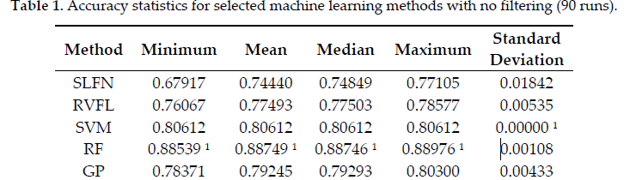
These models can be trained on data generated by simulation testbeds that mimic different driving conditions and fault behaviors. Using a moving average filter can improve accuracy, but it may introduce a delay in detecting faults.
Ayat Najjar et al [14] speaks about a study that was conducted using Long Short-Term Memory (LSTM) networks to predict air compressor failures in trucks and found that while Random Forest (RF) performed slightly better, LSTM models offered more stable results over time.
Srikanth Namuduri et al [15] speaks about the design of electrochemical sensors and the integration of these sensors with DL algorithms in future for getting better results.
Olcay Ersöz et al [17] says in their paper that ,It is seen that the most commonly used algorithm in PdM estimations is the LSTM networks with the percentage of 22%. LSTM networks are networks that work with high efficiency and are often preferred in cases such as determination of long-term dependencies and time series analysis.

3. PROBLEM STATEMENT
In the automotive industry, unexpected vehicle breakdowns can result in high repair costs, reduced vehicle lifespan, and significant downtime. Traditional maintenance strategies, which rely on fixed schedules, often fail to consider the actual condition of vehicle components. This can lead to either premature maintenance, where parts are replaced too early, or unexpected failures, which can cause further damage. As vehicles become more complex, there is a growing need for smarter, data-driven maintenance solutions.
Predictive Maintenance (PdM) offers a promising alternative by utilizing data collected from vehicle sensors to predict when a component is likely to fail. By anticipating failures, PdM enables timely repairs, reducing costs and preventing unexpected breakdowns. Machine Learning (ML) is at the core of PdM systems, as it can analyze vast amounts of data to detect patterns and predict when maintenance is needed. However, applying ML techniques to PdM in automobiles presents several challenges.
These challenges include the need for large, high-quality datasets to train ML models, selecting the right algorithms to ensure accurate predictions, and accounting for variations in vehicle usage and environmental conditions. While significant advancements have been made, much of the existing research focuses on specific components or techniques, leaving gaps in understanding the broader application of ML-based PdM in the automotive industry. This literature review aims to explore current research, evaluate the effectiveness of different ML approaches, and identify areas where further investigation is needed.

4. OBJECTIVES
After reviewing several literature on the topic predictive maintenance in automobiles, the following objectives were derived :
- To develop a predictive model that can anticipate whether a vehicle needs maintenance or not using sensor data.
- To find RUL(Remaining Useful Life) of the vehicle based on sensor data.
- To assess the performance of the proposed predictive model.

5. METHODOLOGY
- Dataset
This Review uses the vehicle_sensor_data.csv from Kaggle for training and testing the model.This dataset contains data for predictive maintenance of vehicles and includes 5,000 records with 9 columns. Here's a breakdown of the columns:
- vehicle_id: Identifies the vehicle (integer).
- operating_hours: Total hours the vehicle has been in operation (integer).
- engine_temp: Current engine temperature (float).
- max_safe_temp: Maximum safe engine temperature (float).
- vibration_level: Current vibration level of the vehicle (float).
- oil_pressure: Current oil pressure in the engine (float).
- rpm: Current revolutions per minute (float).
- remaining_useful_life: Estimated remaining lifespan before maintenance or failure (float).
- needs_maintenance: Whether the vehicle requires maintenance (binary: 1 for yes, 0 for no).
This dataset is suitable for predicting the remaining useful life (RUL) of vehicles or classifying whether maintenance is required based on sensor data. Each record represents a snapshot of the vehicle's operating conditions at a given time.

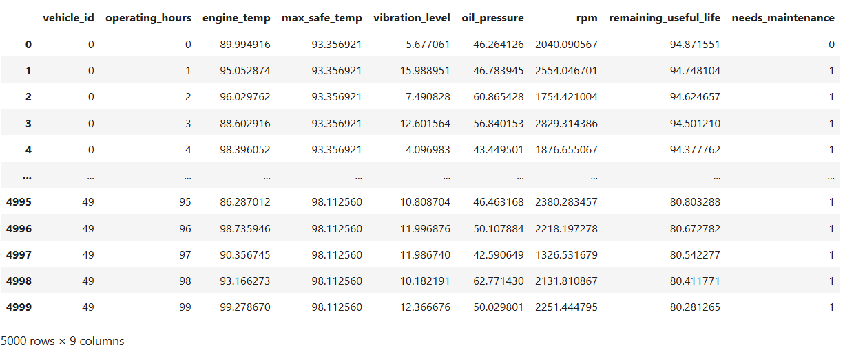
- Detailed Methodology
Two models are used in this approach : an LSTM regressor for RUL(Remaining Useful Life) prediction and a Random Forest (RF) classifier for maintenance prediction. RF makes advantage of aggregated features such as threshold breaches (e.g., exceeding max_safe_temp) and average engine_temp. In contrast, LSTM uses patterns found in sensor readings over time to interpret sequential data and anticipate RUL.
The outputs from both models are combined in the hybrid technique. The RF and LSTM models are first trained separately. The LSTM-predicted RUL is fed back as an extra feature to the RF model during testing or final predictions, increasing the needs_maintenance classification accuracy.

Metrics such as accuracy, precision, recall, and F1-score are assessed to find the RF model's effectiveness in binary classification. Regression metrics such as Mean Absolute Error (MAE) and Root Mean Squared Error (RMSE) are employed for the LSTM model. To make sure it correctly forecasts both RUL and maintenance requirements, the integrated hybrid model is evaluated holistically.

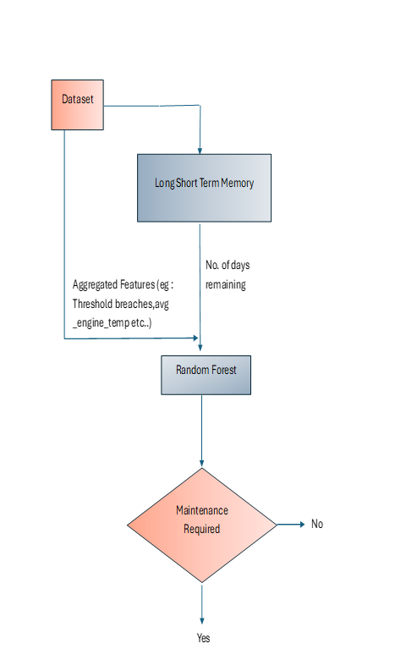

- Train LSTM: Focuses on RUL prediction using sequential sensor data.
- Train RF: Focuses on maintenance classification using aggregated features.
- Combine Predictions: Combines LSTM-predicted RUL with RF inputs.
- RF Classification: Uses the enhanced inputs to classify needs_maintenance.
- Evaluate: Evaluates the hybrid model using classification and regression metric.
5. CONCLUSION
In conclusion, this literature review underscores the growing importance of predictive maintenance (PdM) in the automotive industry, as traditional strategies like preventive maintenance (PvM) and run-to-failure (R2F) become less effective. PdM leverages machine learning (ML) to predict component failures using real-time sensor data, reducing downtime and maintenance costs.
While approaches like recurrent neural networks (RNNs) have shown promise, challenges such as data quality and algorithm selection remain. Overall, PdM is poised to revolutionize vehicle maintenance, especially for autonomous and connected vehicles, though further research is needed to optimize its broader application.

6. REFERENCES

- Arena, Fabio, et al. “Predictive Maintenance in the Automotive Sector: A Literature Review.” Mathematical and Computational Applications, vol. 27, no. 1, 1 Feb. 2022, p. 2.
- Theissler, Andreas & Perez-Velazquez, Judith & Kettelgerdes, Marcel & Elger, Gordon. (2021). Predictive maintenance enabled by machine learning: Use cases and challenges in the automotive industry. Reliability Engineering [?] System Safety. 215. 107864. 10.1016/j.ress.2021.107864.
- GÜVEN, Özlem & Şahin, Hasan. (2022). Predictive Maintenance Based On Machine Learning In Public Transportation Vehicles. Mühendislik Bilimleri ve Araştırmaları Dergisi. 4. 10.46387/bjesr.1093519.
- Yamato, Yoji & Fukumoto, Yoshifumi & Kumazaki, Hiroki. (2016). Proposal of Real Time Predictive Maintenance Platform with 3D Printer for Business Vehicles. International Journal of Information and Electronics Engineering. 6. 10.18178/IJIEE.2016.6.5.640.
- Chaudhuri, Arindam. (2018). Predictive Maintenance for Industrial IoT of Vehicle Fleets using Hierarchical Modified Fuzzy Support Vector Machine. 10.48550/arXiv.1806.09612.
- Sengupta, Prajit & Mehta, Anant & Rana, Prashant. (2023). Predictive Maintenance of Armoured Vehicles using Machine Learning Approaches. 10.48550/arXiv.2307.14453.
- Prof. Khune, Priya, et al. “PREDICTIVE MAINTENANCE in AUTOMOBILE USING IOT and MACHINE LEARNING.” International Research Journal of Modernization in Engineering Technology and Science, vol. 05, no. 03, 6 Mar. 2023.
- Shah, Chirag. (2024). Machine Learning Algorithms for Predictive Maintenance in Autonomous Vehicles. International Journal of Engineering and Computer Science. 13. 26015-26032. 10.18535/ijecs/v13i01.4786.
- Ravi, Aravind & Surabhi, Manogna & Shah, Chirag. (2022). Machine Learning Applications in Predictive Maintenance for Vehicles: Case Studies. International Journal Of Engineering And Computer Science. 11. 25628-25640. 10.18535/ijecs/v11i08.4707.
- Jabari, Youssef, et al. Implementing Models Approach for Predictive Maintenance in the Context of Industry 4.0: A Literature Review and Comparative Analysis.
- Tessaro, Iron & Mariani, Viviana & Coelho, Leandro. (2020). Machine Learning Models Applied to Predictive Maintenance in Automotive Engine Components. Proceedings. 64. 26. 10.3390/IeCAT2020-08508.
- Jafari, Reza. “Machine Learning for Predictive Maintenance in Autonomous Vehicle Fleets.” Journal of Artificial Intelligence Research and Applications, vol. 3, no. 2, Dec. 2023.
- Dhamodharan, Balaji. Optimizing Industrial Operations: A Data-Driven Approach to Predictive Maintenance through Machine Learning Balaji Dhamodharan, Independent Researcher. Mar. 2021.
- Najjar, Ayat & Ashqar, Huthaifa & Hasasneh, Ahmad. (2023). Predictive Maintenance of Urban Metro Vehicles: Classification of Air Production Unit Failures Using Machine Learning.
- Namuduri, Srikanth & Narayanan, Barath & Davuluru, Venkata Salini Priyamvada & Burton, Lamar & Bhansali, Shekhar. (2020). Review—Deep Learning Methods for Sensor Based Predictive Maintenance and Future Perspectives for Electrochemical Sensors. Journal of The Electrochemical Society. 167. 037552. 10.1149/1945-7111/ab67a8.
- Nacchia, M.; Fruggiero, F.; Lambiase, A.; Bruton, K. A Systematic Mapping of the Advancing Use of Machine Learning Techniques for Predictive Maintenance in the Manufacturing Sector. Appl. Sci. 2021, 11, 2546. https://doi.org/10.3390/ app11062546.
- Ersöz, Olcay & Inal, Ali & Aktepe, Adnan & Turker, Ahmet & Ersöz, Süleyman. (2022). A Systematic Literature Review of the Predictive Maintenance from Transportation Systems Aspect. Sustainability. 14. 14536. 10.3390/su142114536.

